Andrew Seamon

CPS 3320-01

Project 1 Proposal

2/21/2021

The Monty Hall problem is a probability puzzle based off the gameshow “Let’s Make a Deal”. In this gameshow, the contestant will choose one of three doors (which either conceal a prize or a goat), the host will reveal what is behind a different door, and then the contestant will have the option to switch doors. I would like to test whether or not it is beneficial to always switch doors after seeing a goat behind one of the other doors. The following diagram explains the concept of the problem:

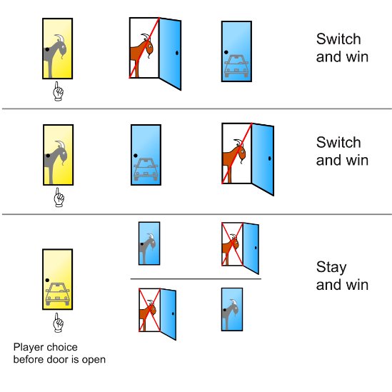

Figure 1: Shown in the diagram is the outcome of each possible option in the Monty Hall Problem. The contestant choses the yellow door, followed by the host revealing a different door, finally allowing the contestant to either switch doors or stay with their initial pick.

I would like to propose that always switching doors will produce a win more often than not switching doors. My dataset will be created at random by the code and subsequently tested. To remove as many variables as possible, I will force the prize to be behind door #1 and allow the contestant to choose on their own (at random). The only problem I can see is that a computer can never produce a 100% random number, which could skew the results slightly. To conduct my analysis, I will complete five runs of 1,000,000 trials. I will be using the ‘random’ library included with Python to produce pseudorandom values. The computation will be done as follows:



As with any project, there is always potential for roadblocks. In this situation, most potential roadblocks can be bunched together as either a lack of knowledge or a need to go above and beyond. Another roadblock could be time simply because I am generating the dataset as the code runs.